Raquel Félix Coutinho 2ºinfonet

1-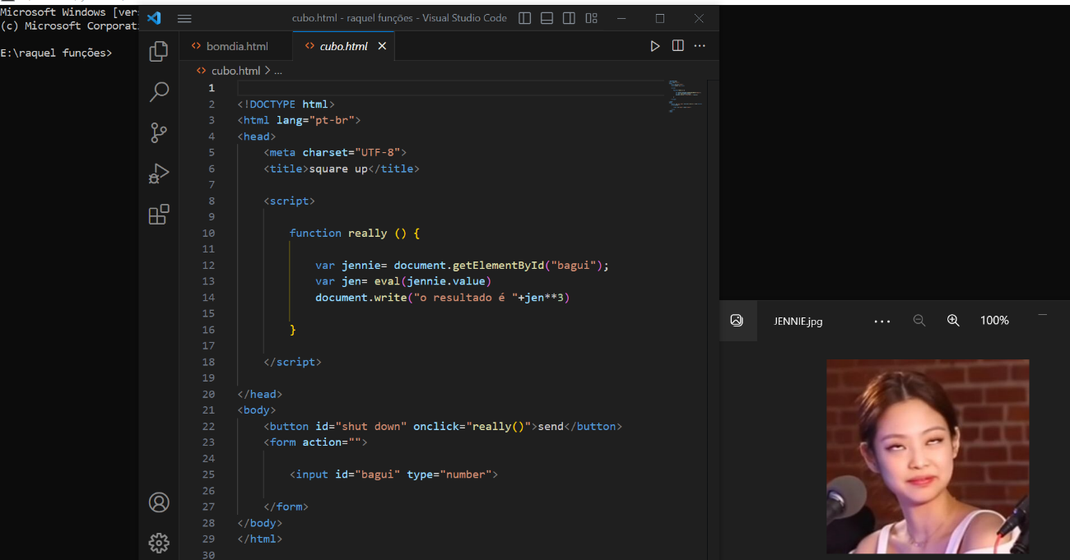

2-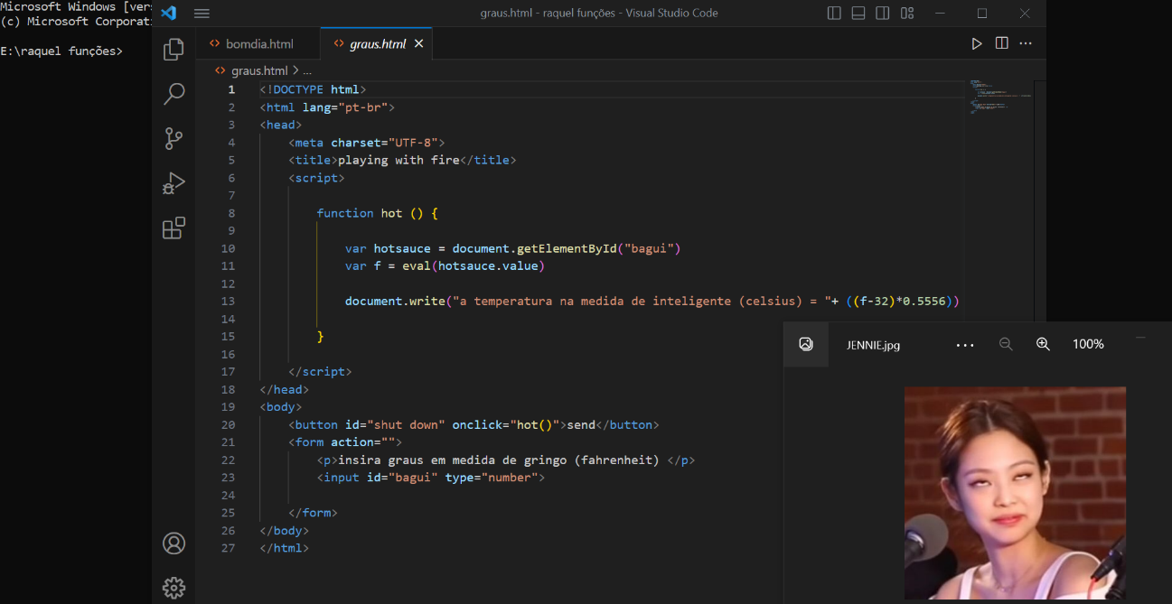

3-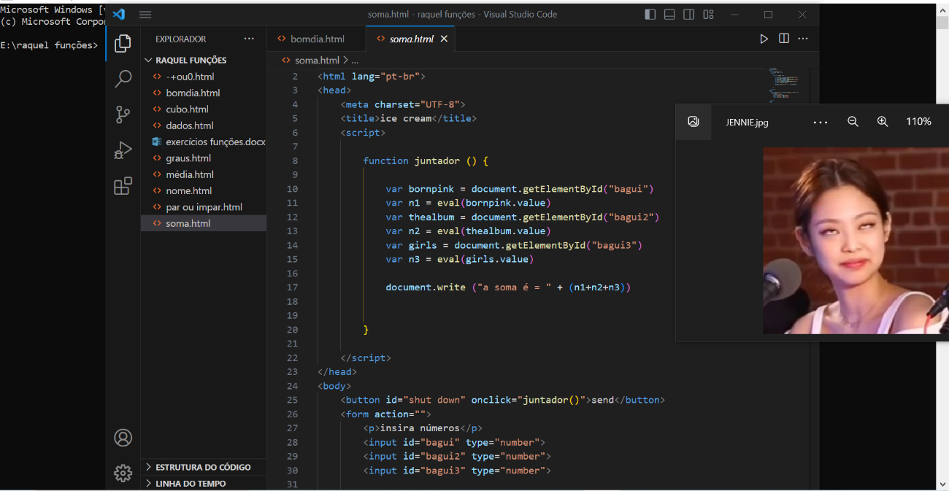

4-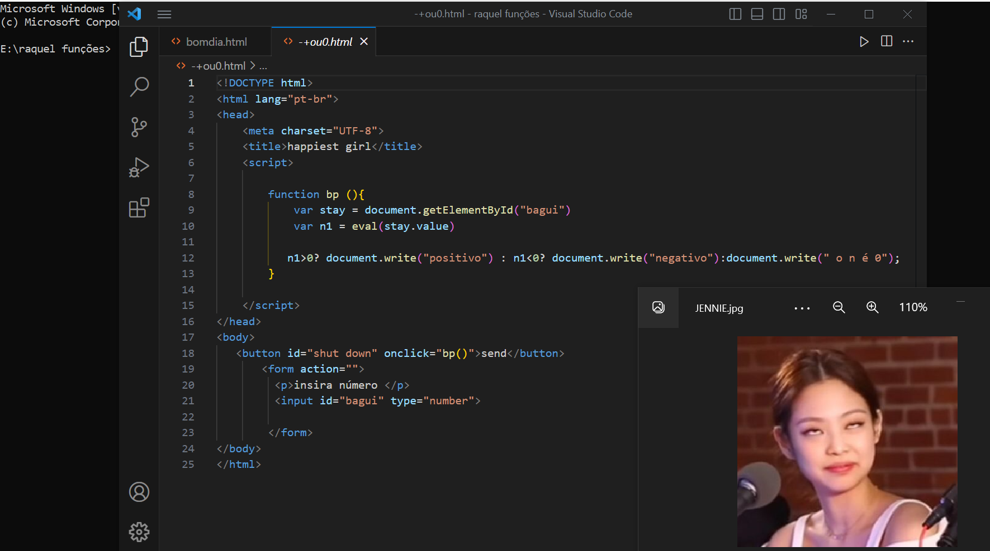

5-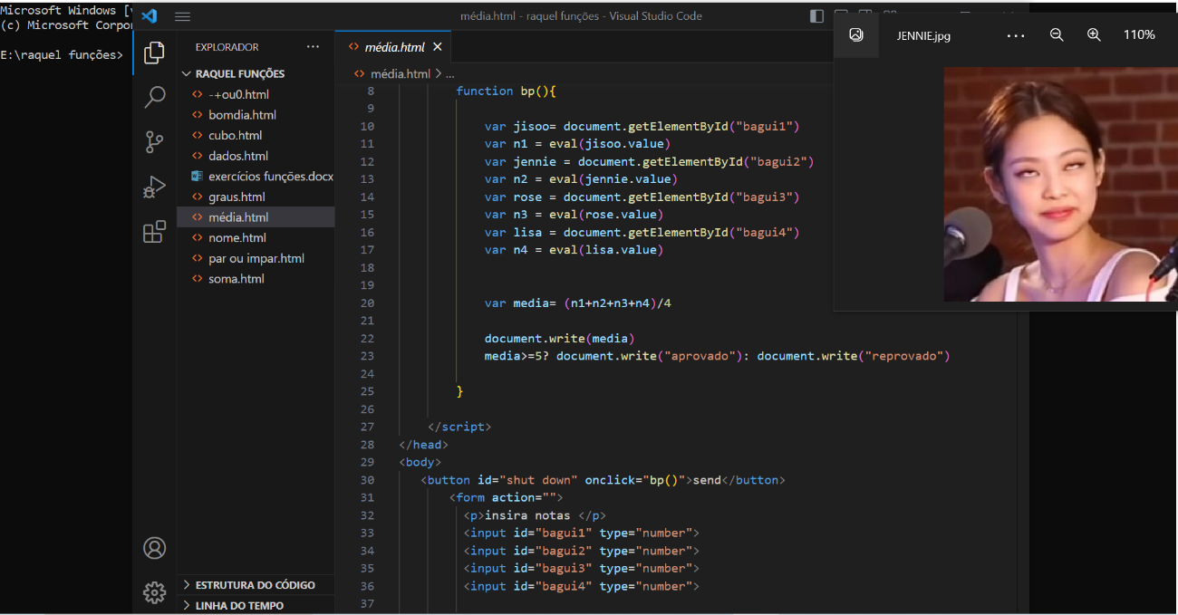

6-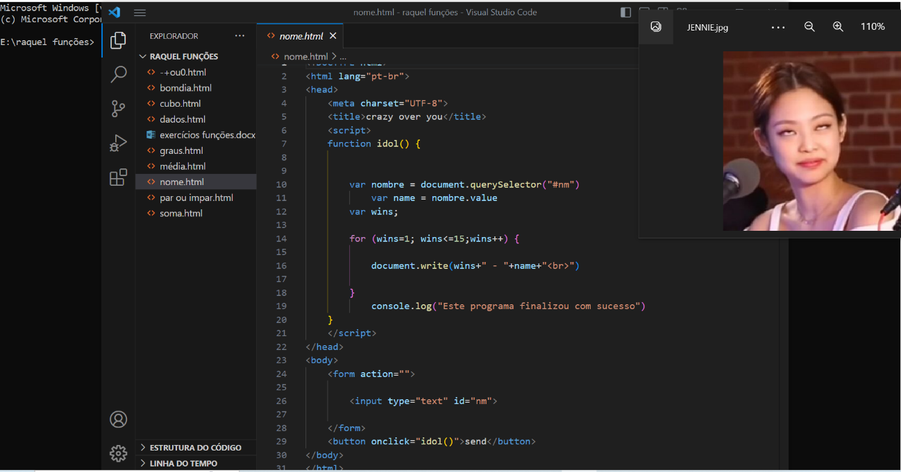

7-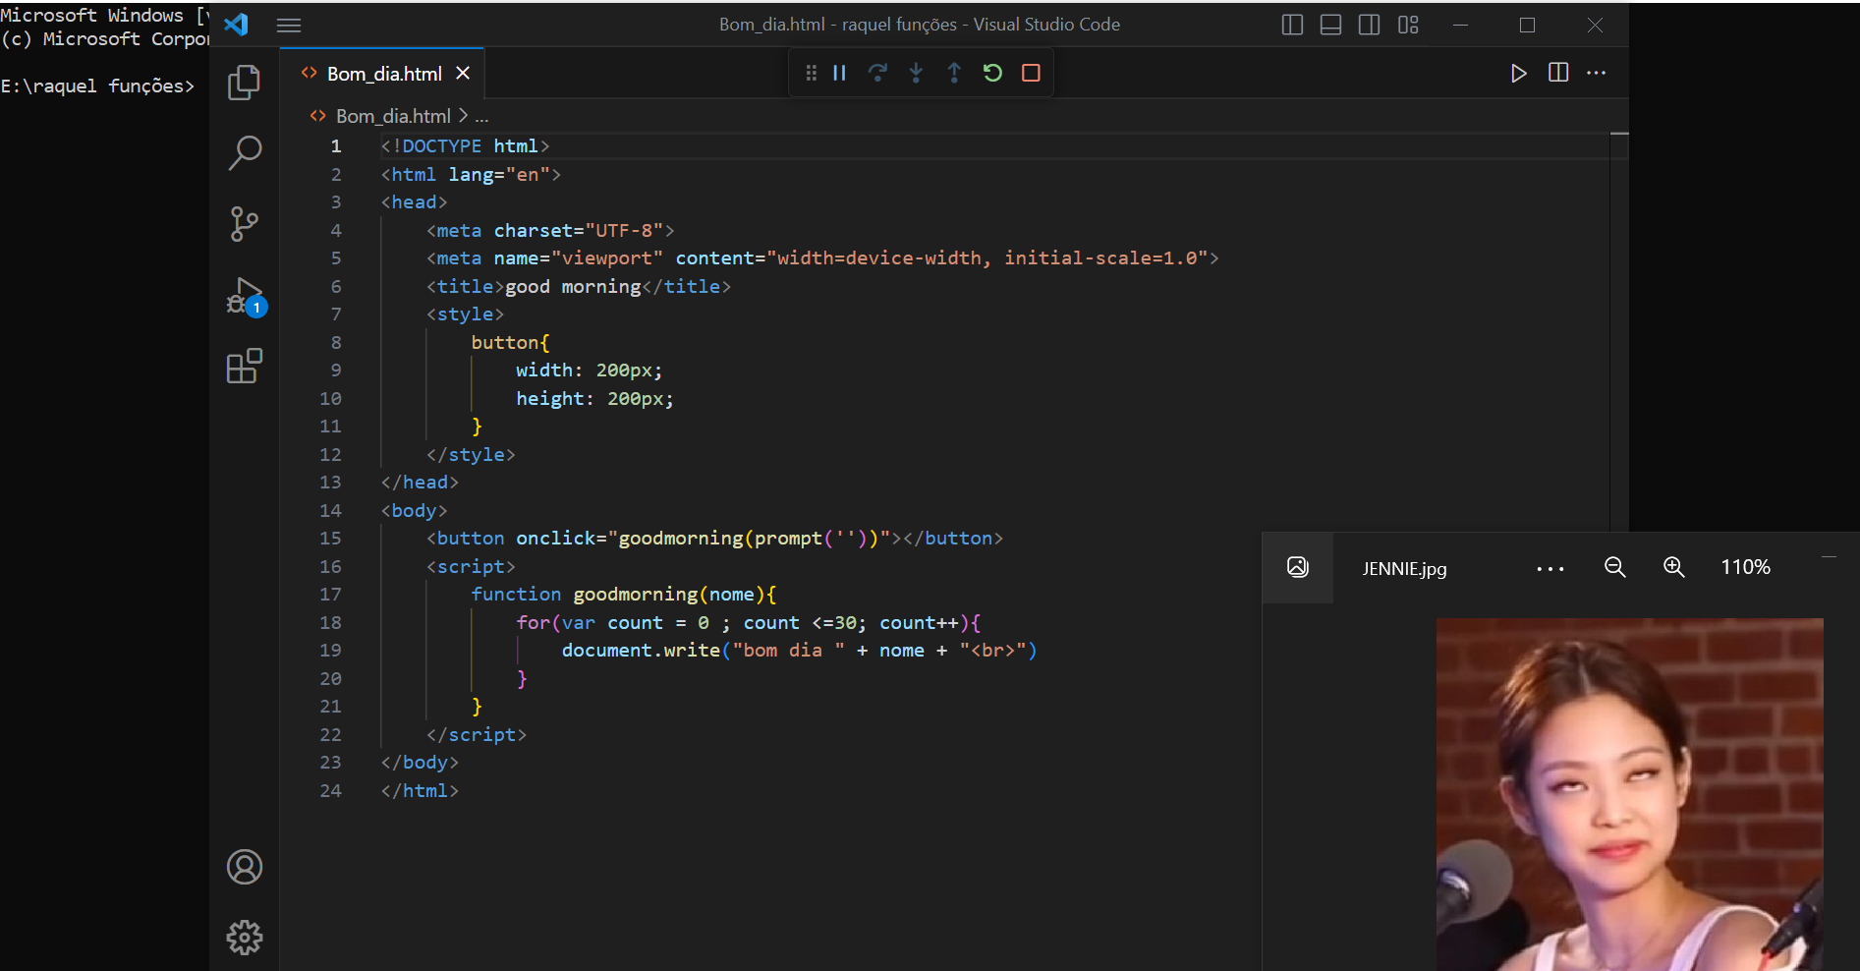

8-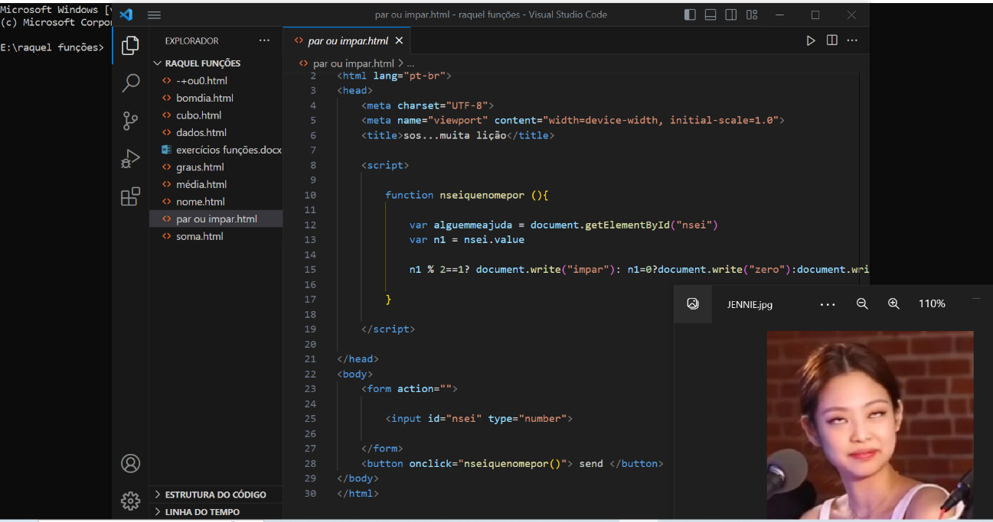

9-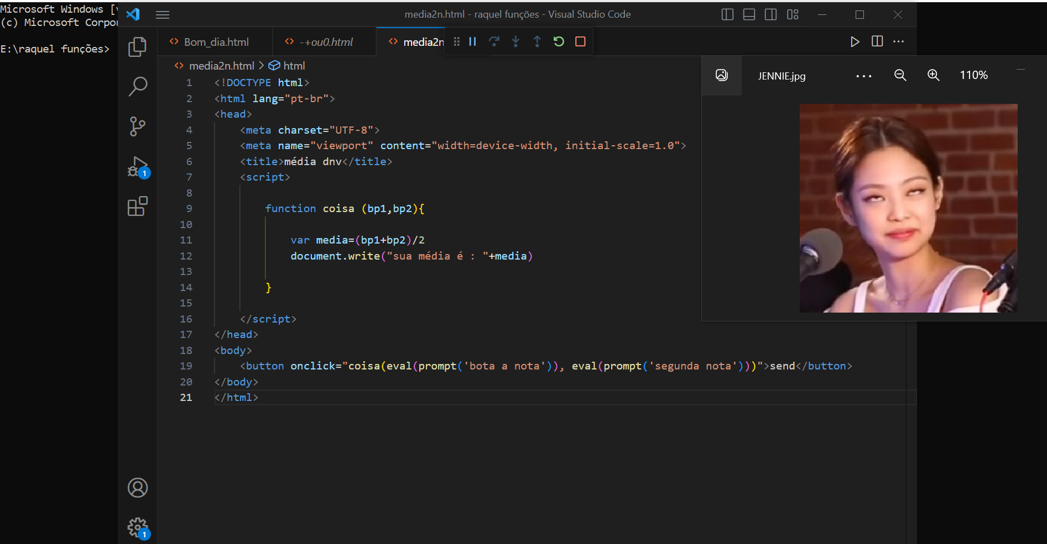

10-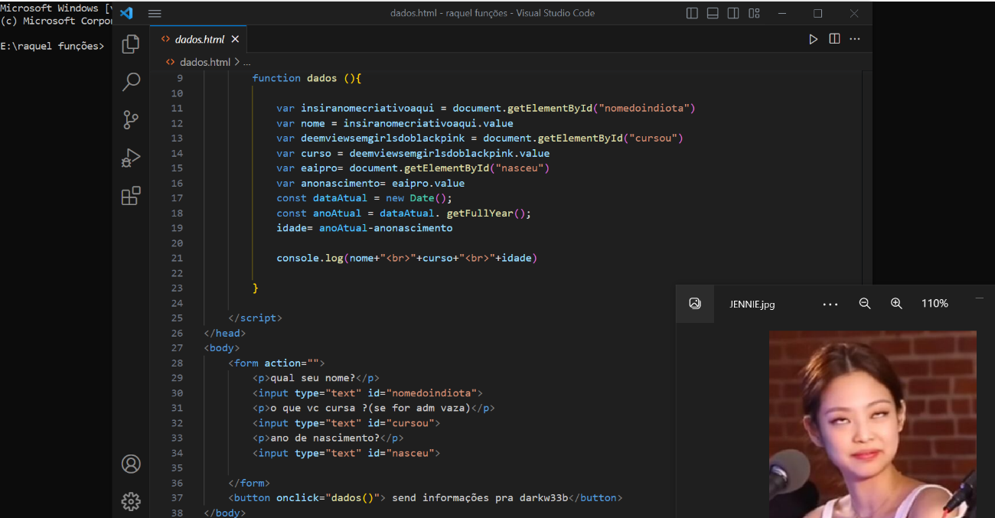

1-

<!DOCTYPE html>

<html lang="pt-br">

<head>

<meta charset="UTF-8">

<title>square up</title>

<script>

function really () {

var jennie= document.getElementById("bagui");

var jen= eval(jennie.value)

document.write("o resultado é "+jen\*\*3)

}

</script>

</head>

<body>

<button id="shut down" onclick="really()">send</button>

<form action="">

<input id="bagui" type="number">

</form>

</body>

</html>

2-<!DOCTYPE html>

<html lang="pt-br">

<head>

<meta charset="UTF-8">

<title>playing with fire</title>

<script>

function hot () {

var hotsauce = document.getElementById("bagui")

var f = eval(hotsauce.value)

document.write("a temperatura na medida de inteligente (celsius) = "+ ((f-32)\*0.5556))

}

</script>

</head>

<body>

<button id="shut down" onclick="hot()">send</button>

<form action="">

<p>insira graus em medida de gringo (fahrenheit) </p>

<input id="bagui" type="number">

</form>

</body>

</html>

3-<!DOCTYPE html>

<html lang="pt-br">

<head>

<meta charset="UTF-8">

<title>ice cream</title>

<script>

function juntador () {

var bornpink = document.getElementById("bagui")

var n1 = eval(bornpink.value)

var thealbum = document.getElementById("bagui2")

var n2 = eval(thealbum.value)

var girls = document.getElementById("bagui3")

var n3 = eval(girls.value)

document.write ("a soma é = " + (n1+n2+n3))

}

</script>

</head>

<body>

<button id="shut down" onclick="juntador()">send</button>

<form action="">

<p>insira números</p>

<input id="bagui" type="number">

<input id="bagui2" type="number">

<input id="bagui3" type="number">

</form>

</body>

</html>

4-<!DOCTYPE html>

<html lang="pt-br">

<head>

<meta charset="UTF-8">

<title>happiest girl</title>

<script>

function bp (){

var stay = document.getElementById("bagui")

var n1 = eval(stay.value)

n1>0? document.write("positivo") : n1<0? document.write("negativo"):document.write(" o n é 0");

}

</script>

</head>

<body>

<button id="shut down" onclick="bp()">send</button>

<form action="">

<p>insira número </p>

<input id="bagui" type="number">

</form>

</body>

</html>

5-<!DOCTYPE html>

<html lang="pt-br">

<head>

<meta charset="UTF-8">

<title>you never know</title>

<script>

function bp(){

var jisoo= document.getElementById("bagui1")

var n1 = eval(jisoo.value)

var jennie = document.getElementById("bagui2")

var n2 = eval(jennie.value)

var rose = document.getElementById("bagui3")

var n3 = eval(rose.value)

var lisa = document.getElementById("bagui4")

var n4 = eval(lisa.value)

var media= (n1+n2+n3+n4)/4

document.write(media)

media>=5? document.write("aprovado"): document.write("reprovado")

}

</script>

</head>

<body>

<button id="shut down" onclick="bp()">send</button>

<form action="">

<p>insira notas </p>

<input id="bagui1" type="number">

<input id="bagui2" type="number">

<input id="bagui3" type="number">

<input id="bagui4" type="number">

</form>

</body>

</html>

6-<!DOCTYPE html>

<html lang="pt-br">

<head>

<meta charset="UTF-8">

<title>crazy over you</title>

<script>

function idol() {

var nombre = document.querySelector("#nm")

var name = nombre.value

var wins;

for (wins=1; wins<=15;wins++) {

document.write(wins+" - "+name+"<br>")

}

console.log("Este programa finalizou com sucesso")

}

</script>

</head>

<body>

<form action="">

<input type="text" id="nm">

</form>

<button onclick="idol()">send</button>

</body>

</html>

7-<!DOCTYPE html>

<html lang="en">

<head>

<meta charset="UTF-8">

<meta name="viewport" content="width=device-width, initial-scale=1.0">

<title>good morning</title>

<style>

button{

width: 200px;

height: 200px;

}

</style>

</head>

<body>

<button onclick="goodmorning(prompt(''))"></button>

<script>

function goodmorning(nome){

for(var count = 0 ; count <=30; count++){

document.write("bom dia " + nome + "<br>")

}

}

</script>

</body>

</html>

8-<!DOCTYPE html>

<html lang="pt-br">

<head>

<meta charset="UTF-8">

<meta name="viewport" content="width=device-width, initial-scale=1.0">

<title>sos...muita lição</title>

<script>

function nseiquenomepor (){

var alguemmeajuda = document.getElementById("nsei")

var n1 = nsei.value

n1 % 2==1? document.write("impar"): n1=0?document.write("zero"):document.write("par")

}

</script>

</head>

<body>

<form action="">

<input id="nsei" type="number">

</form>

<button onclick="nseiquenomepor()"> send </button>

</body>

</html>

9-<!DOCTYPE html>

<html lang="pt-br">

<head>

<meta charset="UTF-8">

<meta name="viewport" content="width=device-width, initial-scale=1.0">

<title>média dnv</title>

<script>

function coisa (bp1,bp2){

var media=(bp1+bp2)/2

document.write("sua média é : "+media)

}

</script>

</head>

<body>

<button onclick="coisa(eval(prompt('bota a nota')), eval(prompt('segunda nota')))">send</button>

</body>

</html>

10-<!DOCTYPE html>

<html lang="en">

<head>

<meta charset="UTF-8">

<meta name="viewport" content="width=device-width, initial-scale=1.0">

<title>h3lp</title>

<script>

function dados (){

var insiranomecriativoaqui = document.getElementById("nomedoindiota")

var nome = insiranomecriativoaqui.value

var deemviewsemgirlsdoblackpink = document.getElementById("cursou")

var curso = deemviewsemgirlsdoblackpink.value

var eaipro= document.getElementById("nasceu")

var anonascimento= eaipro.value

const dataAtual = new Date();

const anoAtual = dataAtual. getFullYear();

idade= anoAtual-anonascimento

console.log(nome+"<br>"+curso+"<br>"+idade)

}

</script>

</head>

<body>

<form action="">

<p>qual seu nome?</p>

<input type="text" id="nomedoindiota">

<p>o que vc cursa ?(se for adm vaza)</p>

<input type="text" id="cursou">

<p>ano de nascimento?</p>

<input type="text" id="nasceu">

</form>

<button onclick="dados()"> send informações pra darkw33b</button>

</body>

</html>